

MERN FULLSTACK REPORT

TITLE : ParkEase – Smart Parking Management and Reservation System

TEAM NUMBER : 17
Name of Student | Register Number
PANUGANTI RAJESH | 99230040711
YEPURI ROHITH | 99230040464
BADINENI VENU GOPAL RAO | 99230040483
MANNAM CHAITHANYA KUMAR | 99230040659
MADEMREDDY MAHESWAR REDDY | 99230040361
Guide By
Ajusha Lalasan
ABSTRACT
ParkEase is a web-based smart parking management and reservation system developed using the MERN stack (MongoDB, Express.js, React.js, and Node.js). The main objective of the project is to reduce urban parking congestion, automate parking-lot operations, provide transparent pricing, and allow drivers to reserve a specific parking space in advance. The system replaces manual ticketing and guess-work searching with a centralised platform that connects drivers, parking operators, and system administrators.
ParkEase provides three main user roles: Driver, Parking Operator, and System Administrator. Drivers can search parking facilities by city, rate, vehicle type, EV charging, security, covered parking, and accessibility, view facilities on an interactive Leaflet / OpenStreetMap map, compare up to three facilities side by side, and select an individual parking space (for example A01 or B04) from a visual floor layout. After booking, the driver receives a digital reservation pass with a unique reference and a simulated QR barrier code.
The system calculates parking fees on the server using vehicle-type rates, duration, and daily-cap discounts. During an active session the driver can see a live duration timer and accrued fee that are derived from timestamps stored in the database, extend the session, and view a checkout receipt. Drivers can also manage their vehicles, save favourite facilities, submit reviews, and receive notifications.
Operators use a Gate Entry and Departure Terminal to simulate barcode scanning and licence-plate lookup, open the entry barrier (which marks the slot as occupied), and open the exit barrier (which frees the slot and calculates the parked duration). They can also create facilities, edit rates and operating hours, generate slots in bulk, and mark bays for maintenance. Administrators have access to platform-wide metrics, user role management, a booking audit table, cascading deletion controls, and Recharts-based analytics for daily reservations, capacity distribution, and peak arrival hours.
The frontend is developed with React 18 (Vite) and Tailwind CSS, while Node.js and Express.js provide RESTful APIs with centralised asynchronous error handling. MongoDB with Mongoose stores facilities, slots, vehicles, and reservations, and an embedded MongoDB Memory Server fallback with an automatic seed-data generator allows the project to run with zero configuration. For academic demonstration, a role-based demo identity system is used instead of production passwords; the report also outlines the production security roadmap (Argon2id/OAuth 2.0, JWT in HTTP-only cookies, server-side RBAC, payment gateway, and ANPR hardware integration).
TABLE OF CONTENTS
TITLE |  | PAGE NO.
ABSTRACT |  | ii
LIST OF TABLES |  | v
LIST OF FIGURES |  | vi
CHAPTER 1 | INTRODUCTION | 1
1.1 | Introduction | 1
1.2 | Problem Statement | 1
1.3 | Objectives of the Project | 2
1.4 | Scope of the Project | 2
CHAPTER 2 | SYSTEM ANALYSIS | 4
2.1 | Introduction | 4
2.2 | Analysis of the Existing System | 4
2.3 | Limitations of the Existing System | 4
2.4 | Proposed System | 5
2.5 | Features of the Proposed System | 5
2.6 | Functional Requirements | 6
2.7 | Non-Functional Requirements | 7
2.8 | Hardware Requirements | 7
2.9 | Software Requirements | 7
2.10 | Feasibility Study | 8
2.11 | Summary | 8
CHAPTER 3 | SYSTEM DESIGN | 9
3.1 | Introduction | 9
3.2 | System Architecture | 9
3.3 | Data Flow Design | 9
3.4 | Database Design | 10
3.5 | Module Design | 11
3.6 | Security Design | 11
3.7 | Summary | 12
CHAPTER 4 | SYSTEM IMPLEMENTATION | 13
4.1 | Introduction | 13
4.2 | Frontend Implementation | 13
4.3 | Backend Implementation | 13
4.4 | Database Implementation | 13
4.5 | Authentication Implementation | 14
4.6 | Reservation and Slot Selection Implementation | 14
4.7 | Pricing and Payment Implementation | 14
4.8 | Operator Gate Terminal and Admin Implementation | 15
4.9 | Summary | 15
CHAPTER 5 | SYSTEM TESTING | 16
5.1 | Introduction | 16
5.2 | Types of Testing | 16
5.3 | Test Cases | 16
5.4 | Testing Result | 17
5.5 | Summary | 17
CHAPTER 6 | CONCLUSION AND FUTURE ENHANCEMENT | 18
6.1 | Conclusion | 18
6.2 | Future Enhancements | 18
6.3 | Final Summary | 18
LIST OF TABLES
TABLES | DETAILS | PAGE NO.
Table 1 | Hardware requirements | 7
Table 2 | Software and technologies | 8
Table 3 | Demo identities and capabilities | 14
Table 4 | Test cases | 17
LIST OF FIGURES
FIGURES | DETAILS | PAGE NO.
Figure 1 | System Architecture | 9
Figure 2 | Level 1 Data Flow Diagram | 10
Figure 3 | Entity Relationship Diagram | 11

CHAPTER 1
INTRODUCTION
1.1 Introduction
ParkEase is a web-based smart parking management and reservation system developed to simplify the process of finding, reserving, using, and paying for parking spaces in urban areas. The system provides a digital platform where drivers can search for parking facilities, choose an exact parking space, and complete the booking process before reaching the location.
Traditional parking facilities rely on manual ticketing, paper records, and drive-in searching for an empty bay. Drivers often circle blocks looking for free spaces, are unsure of the final fee until they exit, and have no way of knowing whether a lot has capacity. Operators, on the other hand, find it difficult to track real-time occupancy and to handle entry and exit consistently.
To overcome these challenges, ParkEase provides an online platform with separate portals for Drivers, Parking Operators, and System Administrators. Drivers can search, compare, and reserve parking; operators can manage facilities, slots, and gate operations; and administrators can monitor and manage the entire platform through analytics and audit tools.
The application is developed using the MERN stack, which consists of MongoDB, Express.js, React.js, and Node.js. Fees are calculated on the server, reservation state transitions are handled atomically, and slot status in MongoDB is kept synchronised with every booking, check-in, check-out, and cancellation.
The main objective of ParkEase is to provide a simple, transparent, and efficient digital parking solution that reduces congestion, saves time for drivers, and gives operators and administrators better control over parking resources.
1.2 Problem Statement
In many cities, parking is still handled through manual or loosely connected systems. These methods lead to several problems, including:
- Drivers spending considerable time searching for an available parking space, which adds to traffic congestion.
- No advance reservation, so a space cannot be guaranteed before arrival.
- Unclear pricing, with the final fee known only at the exit barrier.
- Manual ticketing and record keeping that cause errors and revenue leakage.
- Difficulty for operators in tracking real-time occupancy and slot availability.
- Lack of centralised monitoring, analytics, and auditing for administrators.
These problems affect the efficiency of parking operations and create inconvenience for drivers and operators.
Therefore, a centralised web-based system is required to automate reservations, calculate fees transparently, manage slots and gate operations, and provide analytics. ParkEase is developed to address these issues through an integrated smart parking management and reservation platform.
1.3 Objectives of the Project
The primary objective of the ParkEase project is to develop a web-based platform that simplifies parking discovery, reservation, and management. The specific objectives are:
- To provide an advanced facility search with filters for city, rate, vehicle type, EV charging, security, covered parking, and accessibility.
- To display parking facilities on an interactive map using Leaflet and OpenStreetMap.
- To allow drivers to select an individual parking space from a visual floor layout with real-time total cost calculation.
- To calculate parking fees dynamically on the server using vehicle tiers, duration, and daily-cap discounts.
- To generate a digital reservation pass with a unique reference and a simulated QR barrier code.
- To provide a live active-session timer, fee meter, parking extension, and checkout receipt.
- To provide operators with a gate entry and exit terminal that updates slot status automatically.
- To provide operators with facility, rate, operating-hours, and slot inventory management.
- To provide administrators with user management, analytics, and cascading deletion controls.
- To store and manage facilities, slots, vehicles, and reservations using MongoDB with Mongoose.
1.4 Scope of the Project
The scope of ParkEase is to provide an online platform for managing parking facilities, reservations, and gate operations. The system includes the following major functionalities.
Driver Module
- Searching, filtering, sorting, and comparing parking facilities.
- Viewing facility details, reviews, and pricing rules.
- Selecting a parking slot and creating a reservation.
- Viewing the digital pass, check-in, active session timer, extension, and checkout.
- Managing vehicles, favourites, and notifications.
Operator Module
- Operator dashboard with occupancy, arrivals, and departures.
- Facility creation, rate configuration, operating hours, and deactivation.
- Bulk slot generation, maintenance marking, and slot deletion.
- Gate entry and departure terminal with barcode and licence-plate lookup.
Admin Module
- Platform metrics, booking volume time series, and capacity distribution.
- User directory, role assignment, and activate/suspend controls.
- System-wide booking audit and cascading deletion of facilities, slots, users, and reservations.
Pricing and Payment
Fees are computed on the server from vehicle-type rates, duration, and daily caps. In the current academic version, payment is simulated and no live payment gateway is integrated.
Database Management
MongoDB with Mongoose stores users, facilities, slots, vehicles, reservations, reviews, and notifications. An embedded in-memory MongoDB fallback and automatic seed generator allow the system to run without any external database setup.
CHAPTER 2
SYSTEM ANALYSIS
This chapter explains the requirements, resources, technologies, and overall functionality of the ParkEase system. It describes how the system operates, what facilities it provides to different users, and the requirements needed to develop and run the application.
2.1 Introduction
System analysis is an important phase in software development that helps identify the requirements, functionalities, and resources needed to develop a software application.
The ParkEase system is designed to simplify parking search, reservation, and operation. It provides a centralised web-based platform that connects drivers, parking operators, and system administrators through separate interfaces.
The system allows drivers to search for facilities, choose a slot, reserve it, and manage their parking session. Operators can manage facilities, slots, and gate operations, while administrators monitor and manage the platform through analytics and audit tools. The analysis phase identifies the functional and non-functional requirements, hardware and software requirements, and feasibility of the proposed application.
2.2 Analysis of the Existing System
In a traditional parking system, drivers generally drive into a lot, look for any free space, and collect a paper ticket or pay a manual attendant. Records are maintained on paper or in isolated billing software.
The existing approach may involve the following activities:
- Drivers drive around the facility to find a free space.
- Entry time is recorded manually or on a paper ticket.
- Fees are calculated by the attendant at the exit.
- Occupancy is estimated visually by the staff.
- Management receives reports only after manual consolidation.
These processes increase waiting time at the gate and make parking management less convenient.
2.3 Limitations of the Existing System
The traditional parking approach has several limitations:
- Time Consumption: Drivers spend time searching for free spaces and queuing at entry and exit gates.
- No Reservation: A space cannot be guaranteed before arrival.
- Opaque Pricing: The final fee is unknown until checkout and is open to calculation errors.
- Manual Record Management: Paper tickets and registers can be lost or recorded incorrectly.
- No Real-Time Occupancy: Operators cannot see accurate slot status at any moment.
- Limited Visibility for Drivers: Facility features such as EV charging, covered parking, or accessibility are not known in advance.
- Lack of Analytics: Peak hours and utilisation cannot be analysed without manual effort.
2.4 Proposed System
The proposed ParkEase system is a web-based smart parking management and reservation application developed using the MERN stack. It provides separate dashboards and workflows for drivers, operators, and administrators.
The application uses MongoDB to store facility, slot, vehicle, and reservation information. Express.js and Node.js handle backend operations and fee calculations, while React.js provides an interactive frontend with a map view and a visual slot layout.
Reservation actions and slot status are kept in sync in the database, so cancelling a booking immediately frees the slot and a gate entry immediately marks it as occupied. Role-based access is applied through a demonstration identity system for academic evaluation.
The proposed system aims to reduce search time, make pricing transparent, automate gate operations, and give administrators complete visibility of platform activity.
2.5 Features of the Proposed System
ParkEase provides the following major features:
1. Driver Management
- Role login and one-click persona switching.
- Driver dashboard with upcoming booking alert and spending summary chart.
- Vehicle registration for cars, motorcycles, and SUVs with EV indicator.
- Favourites and notifications inbox.
2. Facility Discovery
- Advanced filters, sorting, and toggleable Leaflet map view.
- Facility details with image gallery, pricing rules, amenities, and reviews.
- Side-by-side comparison of up to three facilities.
- Cost calculator with vehicle tiers, duration slider, and daily-cap discounts.
3. Reservation and Session Management
- Interactive slot selection with EV charging markers.
- Digital pass with unique reference (PK…) and simulated QR code.
- Check-in, live duration timer, accrued fee meter, extension, and checkout receipt.
- Cancellation that immediately frees the slot.
4. Operator Management
- Dashboard with total spaces, occupancy, arrivals, and departures.
- Facility, rate, and operating-hours management.
- Bulk slot generator and maintenance toggle.
- Gate terminal with barcode and licence-plate lookup.
5. Admin Management
- Platform metrics and system-wide booking audit.
- User role assignment and suspension.
- Recharts analytics and cascading deletion controls.
6. Platform Quality
- Cinematic ambient motion background.
- Global error boundaries with quick reload and recovery.
- Zero-configuration database with automatic seed data.
2.6 Functional Requirements
Functional requirements describe the operations and services that the system must provide to its users. The functional requirements of ParkEase are classified according to the three user roles.
Driver Functional Requirements
- The system must allow drivers to sign in through the driver portal or the universal login.
- Drivers must be able to search and filter facilities by city, rate, vehicle type, EV, security, covered, and accessible options.
- Drivers must be able to view facility details, pricing rules, and reviews, and submit a review.
- Drivers must be able to select an individual slot and see the total cost before confirming.
- The system must generate a reservation reference and a digital pass.
- Drivers must be able to check in, view the active session timer and accrued fee, extend, and check out.
- Drivers must be able to cancel a booking, which must free the slot immediately.
- Drivers must be able to register, set a primary, and delete vehicles with safeguards.
Operator Functional Requirements
- The system must provide a separate login portal for operators.
- Operators must be able to create facilities, edit vehicle rates and operating hours, and deactivate lots.
- Operators must be able to generate slots in bulk, mark bays for maintenance, and delete slots.
- Operators must be able to look up a reservation by barcode or licence plate.
- Opening the entry barrier must mark the slot occupied; opening the exit barrier must free the slot and calculate duration.
Admin Functional Requirements
- The system must provide a separate administrator login portal.
- Administrators must be able to view platform metrics, booking volume, and capacity distribution.
- Administrators must be able to assign roles and activate or suspend users.
- Administrators must be able to delete facilities (cascading to slots and reservations), slots, users, and reservation records.
- Administrators must be able to reset sessions or completely re-seed the database from Settings.
2.7 Non-Functional Requirements
Non-functional requirements describe the quality attributes and performance expectations of the application. The following are considered for ParkEase.
- Security: Access is restricted by user role; the report documents the production-grade authentication roadmap (Argon2id, JWT cookies, server-side RBAC).
- Usability: A clean navy, slate, and emerald interface with a persistent role-switcher banner makes navigation simple for all users.
- Performance: The system should process searches, reservations, and dashboard queries efficiently.
- Reliability: Reservation transitions are atomic, and slot status in MongoDB must always match the reservation state.
- Scalability: Additional facilities, slots, and users can be added without changes to the architecture.
- Maintainability: Separate frontend components, backend routes, and Mongoose models allow individual modules to be updated independently.
- Accessibility: Responsive layouts using Tailwind CSS support different screen sizes and devices.
- Portability: An embedded MongoDB Memory Server fallback lets the system run without installing a database.
2.8 Hardware Requirements
The following hardware requirements are suitable for developing and running the ParkEase application.
Component | Minimum requirement
Processor | Intel Core i3 or equivalent
RAM | 4 GB (8 GB recommended)
Hard Disk | 10 GB free space
Display | Standard monitor
Input Devices | Keyboard and mouse
Network | Internet connection (required for map tiles)
Table 1 Hardware requirements
2.9 Software Requirements
The following software and technologies are used in the development of ParkEase.
Software / Technology | Purpose
React 18 with Vite | Frontend framework and build tool
Tailwind CSS 3.4 | Styling and responsive design
React Router v6 | Client-side routing
Axios | HTTP client with demo identity interceptor
Leaflet and OpenStreetMap | Interactive map view
Recharts | Data visualisation and analytics charts
Lucide React | Icon library
Node.js | Backend runtime environment
Express.js | RESTful API development
MongoDB and Mongoose | Database and object modelling
MongoDB Memory Server | Zero-config embedded database fallback
VS Code | Development environment
Postman | API testing
Table 2 Software and technologies
2.10 Feasibility Study
A feasibility study is conducted to determine whether the proposed system can be developed and operated successfully. ParkEase is evaluated on the following factors.
Technical Feasibility
The project is technically feasible because it uses widely available technologies such as React.js, Node.js, Express.js, and MongoDB. These provide the facilities for interactive pages, backend APIs, map and chart integration, and database operations. The MERN stack also supports modular development and future enhancement.
Economic Feasibility
The project is economically feasible because all major technologies used, including VS Code, Node.js, React, Express, MongoDB, Leaflet, OpenStreetMap, and Recharts, are open-source and free to use. No licensed software is required.
Operational Feasibility
The system is operationally feasible because it offers a simple interface for drivers, operators, and administrators. Drivers can reserve a space without manual procedures, operators can run the gate terminal from a browser, and administrators can monitor the platform from a single dashboard. Only basic computer or smartphone knowledge is required.
Schedule Feasibility
The project is developed in modules such as search, slot selection, reservation, gate terminal, and analytics. This modular approach makes it easier to develop, test, and complete the project within the available time.
2.11 Summary
This chapter discussed the system analysis of the ParkEase application, including the existing system, its limitations, the proposed system, functional and non-functional requirements, hardware and software requirements, and the feasibility study. The analysis establishes the foundation for the system design and implementation phases discussed in the following chapters.
CHAPTER 3
SYSTEM DESIGN
3.1 Introduction
System design explains the structure, modules, database, and workflow of the ParkEase project. It describes how drivers, operators, and administrators interact with the application.
3.2 System Architecture
ParkEase follows a three-tier MERN architecture:
- Frontend: React 18 with Vite, Tailwind CSS, React Router, Leaflet, and Recharts provide the user interface.
- Backend: Node.js and Express.js expose RESTful APIs, perform price calculation, and manage reservation transitions.
- Database: MongoDB with Mongoose stores all persistent data, with an embedded Memory Server fallback.
- State Management: React Context API manages authentication, toast messages, and notifications.
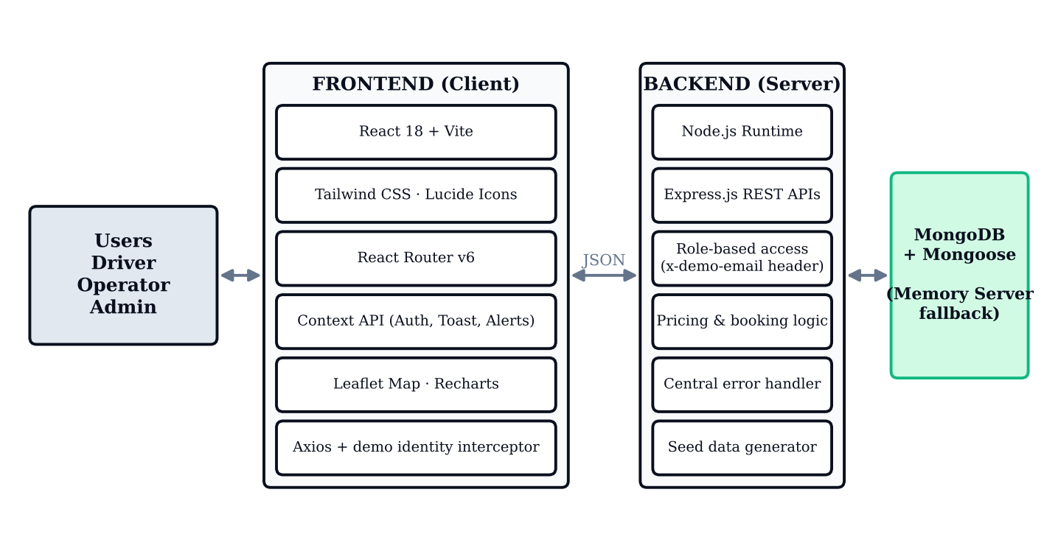
Fig 1: System Architecture
3.3 Data Flow Design
ParkEase acts as the central process connecting drivers, operators, and administrators.
Level 0
- Driver sends search criteria and booking details and receives the reservation pass.
- Operator scans passes or plates at the gate and manages facilities and slots.
- Admin manages users and monitors platform activity.
Level 1 – Data Flow
- The user selects a role and signs in through the demo identity system.
- The driver searches and filters facilities and opens a facility.
- The driver selects a slot; the server calculates the total cost.
- The reservation is stored in MongoDB and the slot is reserved.
- At the gate, the operator opens the entry barrier; the slot becomes occupied.
- During the session, the driver sees the timer and accrued fee derived from stored timestamps.
- At exit, the operator opens the exit barrier; the slot is freed and the duration and fee are finalised.
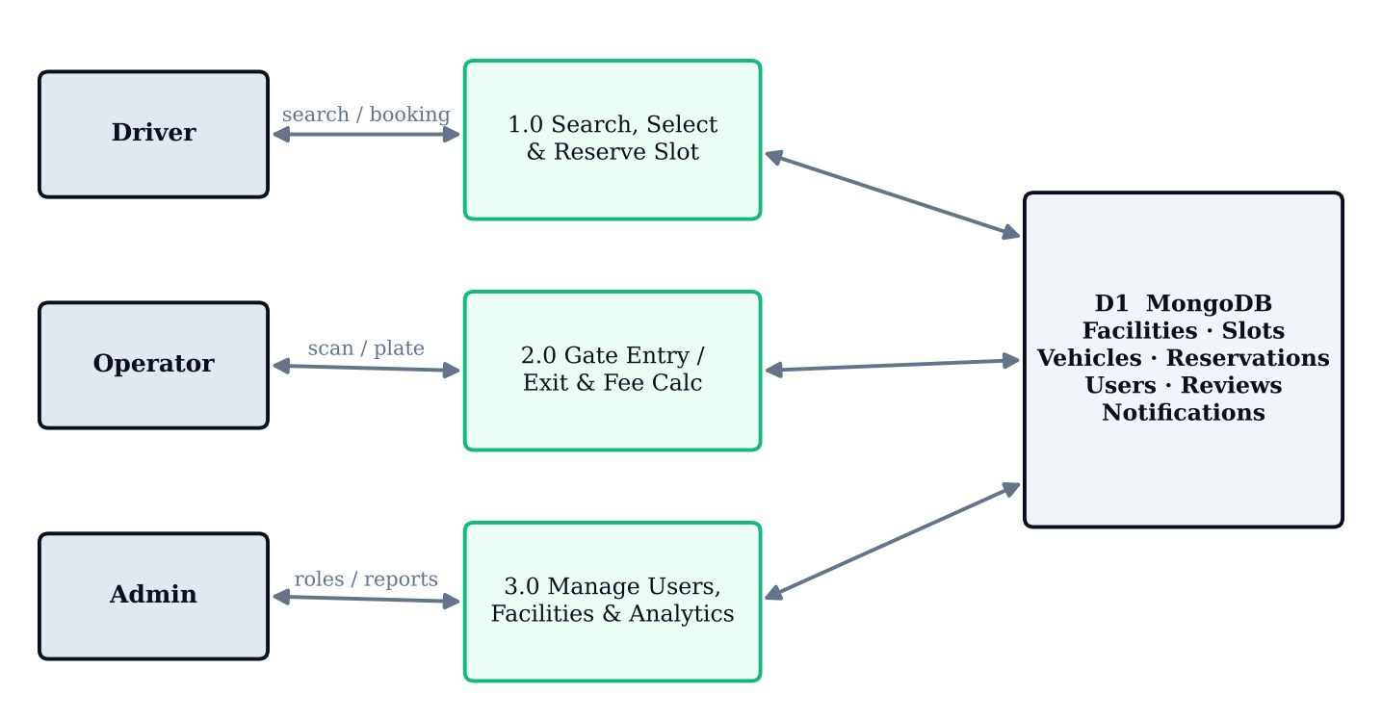
Fig 2: Level 1 Data Flow Diagram
3.4 Database Design
The project uses MongoDB to store application data and Mongoose to define and manage models. The main collections are:
- Users: Stores name, email, role (driver, operator, admin), and active/suspended status.
- Facilities: Stores name, city, address, vehicle rates, daily cap, operating hours, amenities, and active status.
- Slots: Stores the facility reference, label (for example A01), EV flag, and status (available, occupied, maintenance).
- Vehicles: Stores the owner reference, plate number, type, EV indicator, and primary flag.
- Reservations: Stores driver, facility, slot, and vehicle references, start and end time, check-in and check-out timestamps, status, reference number, and fee.
- Reviews, Favourites, and Notifications: Store driver feedback, bookmarked facilities, and activity messages.
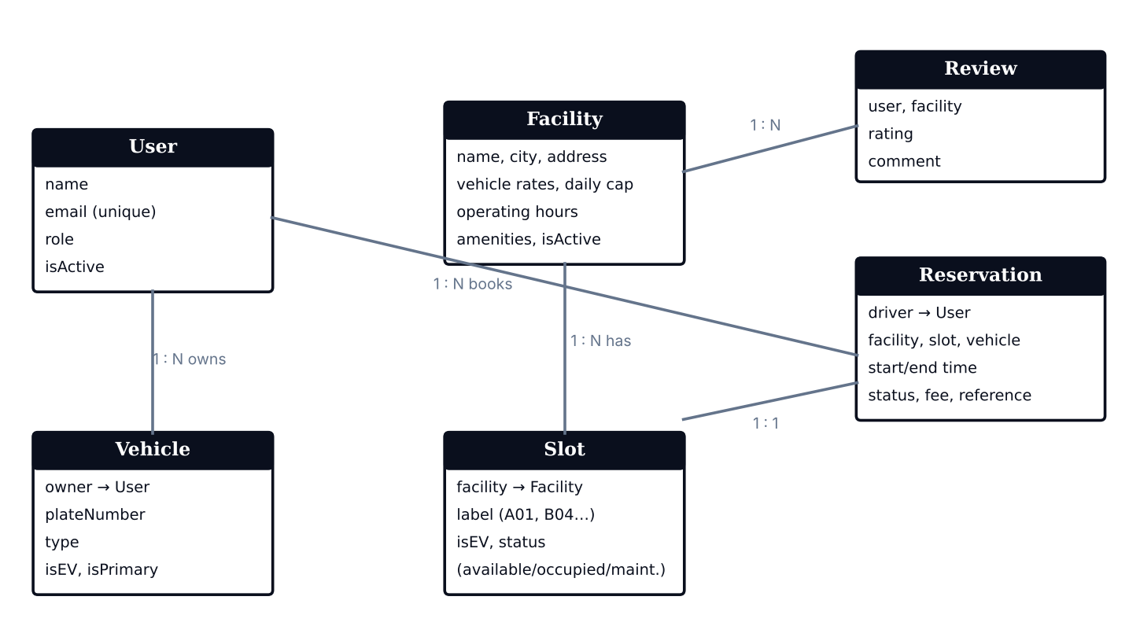
Fig 3: Entity Relationship Diagram
3.5 Module Design
The system is divided into the following modules:
1. Driver Module
- Login, dashboard, and facility search.
- Slot selection and reservation.
- Active session, vehicles, favourites, and notifications.
2. Facility and Slot Module
- Facility details, rates, and operating hours.
- Slot generation, maintenance, and status tracking.
3. Reservation Module
- Creates and cancels bookings.
- Keeps slot status synchronised with reservation state.
4. Pricing and Payment Module
- Calculates fees from vehicle tier, duration, and daily cap.
- Provides simulated QR confirmation and exit receipt.
5. Operator Gate Module
- Barcode and licence-plate lookup.
- Entry and exit barrier operations.
6. Admin Module
- Analytics, user management, audit, and deletion controls.
3.6 Security Design
For academic evaluation, ParkEase uses a demonstration identity system based on a client-side header (x-demo-email) so that roles can be assessed and switched easily. The following security measures are part of the current design and the production roadmap:
- Role-Based Access: Pages and actions are restricted according to the Driver, Operator, or Admin role.
- Centralised Error Handling: Asynchronous errors are handled in one place and return consistent responses.
- Atomic Transitions: Reservation state changes are atomic, preventing double booking of a slot.
- Delete Safeguards: Vehicle deletion and admin cascade deletion include safeguards.
For real-world deployment, the following would be integrated: password hashing with Argon2id or OAuth 2.0 PKCE, signed JWTs in HTTP-only SameSite=Strict Secure cookies, server-side RBAC middleware on every endpoint, a payment gateway such as Razorpay or Stripe with signature verification, and ANPR cameras with barrier relay APIs.
3.7 Summary
This chapter explained the system architecture, data flow, database structure, modules, and security design of ParkEase. These design components provide a structured foundation for developing and maintaining the application.
CHAPTER 4
SYSTEM IMPLEMENTATION
4.1 Introduction
System implementation is the process of developing the ParkEase application using the MERN stack. The system provides separate interfaces for drivers, operators, and administrators to manage parking reservations and operations.
4.2 Frontend Implementation
The frontend is developed using React 18 with Vite, Tailwind CSS 3.4, and JavaScript, using a deep navy, slate gray, and emerald green colour theme.
- Public pages: Home, Find Parking, Facility Details, Slot Selection, Confirmation, Compare, Calculator, Login, FAQ, and About.
- Driver pages: Dashboard, My Reservations, Active Session, Vehicles, Favourites, and Notifications.
- Operator pages: Dashboard, Facility Management, Slot Inventory, and Gate Terminal.
- Admin pages: Dashboard, User Management, Analytics, and Settings.
- React Router v6 handles navigation, Axios handles API calls, and the Context API manages authentication, toasts, and notifications.
- Leaflet with OpenStreetMap renders the map view; Recharts renders analytics; Lucide React provides icons.
4.3 Backend Implementation
The backend is developed using Node.js and Express.js and exposes RESTful APIs.
- Handles identity resolution from the demo header and role checks.
- Processes reservation, check-in, extension, checkout, and cancellation requests.
- Calculates parking fees and daily-cap discounts on the server.
- Provides gate entry and exit endpoints that update slot status.
- Provides admin APIs for analytics, user management, and cascading deletion.
- Uses centralised asynchronous error handling for consistent error responses.
The server binds to port 5001 (or 5000), checks for MongoDB, and starts the in-memory database if no local daemon is available.
4.4 Database Implementation
MongoDB is used to store application data, with Mongoose for schema definition and database operations. If no local MongoDB is running, an embedded MongoDB Memory Server is started and an automated seed generator creates sample facilities, slots, vehicles, and reservations. The main data includes:
- User details and roles.
- Facility details, rates, and operating hours.
- Slot labels, types, and status.
- Reservation details, including timestamps, fee, and status.
- Reviews, favourites, and notifications.
The Settings page provides controls to reset sessions or completely re-seed the database.
4.5 Authentication Implementation
ParkEase implements a demonstration identity system for academic grading. Instead of passwords or OTPs, the client sends an x-demo-email header through an Axios interceptor, and the server resolves the matching user and role.
Role | Email | Name | Key Capabilities
Driver | driver@parkease.demo | Dev Driver | Search, reserve, session timer, vehicles, reviews
Driver 2 | user@parkease.demo | Uma User | Independent bookings
Operator | operator@parkease.demo | Om Operator | Gate terminal, slot maintenance, capacity
Admin | admin@parkease.demo | Alex Admin | Analytics, user roles, booking audit
Table 3 Demo identities and capabilities
- Three dedicated login portals are provided: /login/driver, /login/operator, and /login/admin, along with the universal gateway at /login.
- A persistent top banner and profile menu allow instant role switching without losing application state.
4.6 Reservation and Slot Selection Implementation
The reservation process allows drivers to:
- Search and filter facilities and open a facility.
- Open the slot selection page and view the visual floor layout.
- Select an available slot (EV slots are marked).
- Review the real-time total cost.
- Confirm the reservation and receive the digital pass.
- Check in on arrival and use the active session page.
The reservation is stored in MongoDB and linked to the driver, facility, slot, and vehicle. Cancelling or unreserving immediately returns the slot to the available state.
4.7 Pricing and Payment Implementation
Fees are calculated on the server so that the amount cannot be altered from the browser. The calculation considers the vehicle tier, the duration, and the facility daily cap. The cost calculator page shows the estimator before booking, and the active session page shows a live accrued fee derived from the stored check-in timestamp.
The confirmation page shows a simulated QR barrier code. Note: actual online payment processing is not integrated in the current version; the production roadmap proposes Razorpay or Stripe with signature-verified webhooks.
4.8 Operator Gate Terminal and Admin Implementation
Operator Gate Terminal
- Barcode scanner simulation and licence-plate lookup.
- Open entry barrier: marks the slot as occupied.
- Open exit barrier: frees the slot and calculates parked duration.
- Facility and slot inventory management, including bulk space generator (for example Section E with 20 spaces).
Admin Portal
- Dashboard with platform metrics, booking time series, capacity distribution, and audit table.
- User directory with role dropdown and active/suspend toggle.
- Recharts graphs for daily reservations, facility capacity, and peak arrival hours.
- Unrestricted cascading deletion of facilities, slots, users, and reservation audit records.
4.9 Summary
The ParkEase system is implemented using the MERN stack. It connects the frontend, backend, and MongoDB database to support facility search, slot reservation, server-side pricing, live session tracking, gate operations, and administrative analytics.
CHAPTER 5
SYSTEM TESTING
5.1 Introduction
System testing is performed to check whether the ParkEase application works correctly. It helps identify errors and ensures that the main features function as expected.
5.2 Types of Testing
- Unit Testing: Checks individual components and functions such as the fee calculation.
- Integration Testing: Checks communication between the frontend, backend, and database.
- Functional Testing: Verifies that application features work according to requirements.
- Validation Testing: Checks whether entered details such as vehicle plates are accepted correctly.
- User Interface Testing: Checks layout, navigation, map view, and responsiveness.
- Role-Based Testing: Verifies that each role sees only its permitted pages.
5.3 Test Cases
No. | Test Case | Expected Result | Status
1 | Role login / persona switch | User enters the selected role portal without losing state. | Pass
2 | Facility search and filters | Only facilities matching the filters are displayed. | Pass
3 | Map view toggle | Facilities are shown as markers on the Leaflet map. | Pass
4 | Compare facilities | Up to three facilities are compared with normalised rates. | Pass
5 | Slot selection | Selected slot is highlighted and total cost is displayed. | Pass
6 | Reservation creation | Reservation is saved and a unique PK reference is generated. | Pass
7 | Cancel reservation | Booking is cancelled and the slot becomes available. | Pass
8 | Check-in and active timer | Session timer and fee meter start from stored timestamps. | Pass
9 | Extend and checkout | Session is extended and an exit receipt is shown. | Pass
10 | Vehicle management | Vehicle is added, set as primary, and delete safeguards work. | Pass
11 | Gate entry barrier | Slot is marked occupied after entry. | Pass
12 | Gate exit barrier | Slot is freed and parked duration is calculated. | Pass
13 | Slot generator and maintenance | Bulk slots are created and maintenance slots cannot be booked. | Pass
14 | Admin role change / suspend | User role or status is updated. | Pass
15 | Admin cascade deletion | Facility deletion removes its slots and reservations. | Pass
16 | Database reset (Settings) | Sessions are reset or the database is re-seeded. | Pass
Table 4 Test cases
5.4 Testing Result
The test cases were designed to verify the major functions of the ParkEase application, including role login, facility search, slot reservation, cancellation, live session tracking, gate operations, and admin management. All listed functions performed as expected during demonstration testing.
5.5 Summary
System testing helps verify the functionality and reliability of the ParkEase application. It ensures that the main modules work together and support the complete parking reservation lifecycle.
CHAPTER 6
CONCLUSION AND FUTURE ENHANCEMENT
6.1 Conclusion
The ParkEase project was developed to simplify the process of finding, reserving, and managing parking spaces through an online platform. It uses the MERN stack (MongoDB, Express.js, React.js, and Node.js) to provide an organised and user-friendly application.
The system allows drivers to search facilities, choose an exact slot, reserve it, and track the parking session with a live timer and fee meter. Operators can manage facilities and run gate operations, while administrators can monitor and manage the platform through analytics and audit tools.
The project reduces parking search time, makes pricing transparent, and automates slot status management. The identity system and payment process are currently demonstration-only and do not use production authentication or a real payment gateway.
6.2 Future Enhancements
The following features can be added in future versions:
- Production Authentication: Argon2id password hashing or OAuth 2.0 PKCE with refresh tokens.
- Session Security: Signed JWTs in HTTP-only, SameSite=Strict, Secure cookies.
- Server-Side RBAC: Role-based authorisation middleware on every endpoint.
- Payment Gateway: Razorpay or Stripe integration with cryptographic webhook signature verification.
- ANPR Hardware: Automatic licence plate recognition cameras and barrier relay APIs.
- SMS and Email Notifications: Booking confirmations and reminders.
- Mobile Application: Android and iOS applications.
- Advanced Analytics: Demand forecasting and dynamic pricing.
6.3 Final Summary
ParkEase provides a digital solution for smart parking management and reservation. It demonstrates how web technologies can make parking simpler, faster, and more organised. Future enhancements can make the system more secure, efficient, and useful for drivers, operators, and administrators.

